**Mutahra Salman**

**21-11447**

**Software Quality Assurance CSSE 351 Section A**

**Assignment 3**

**Introduction** ­­­

The task is to install and create a CI/ CD pipeline for a project using Jenkins tool. Followings are the screenshots provided for the execution of the task. I have used a Social Media MERN App as the sample project. The CI/CD pipeline created first initializes itself, then pulls code from Git repo, then builds it then runs some tests on it which essentially are nightwatchJS FE unit tests:

Code Structure as on Github:

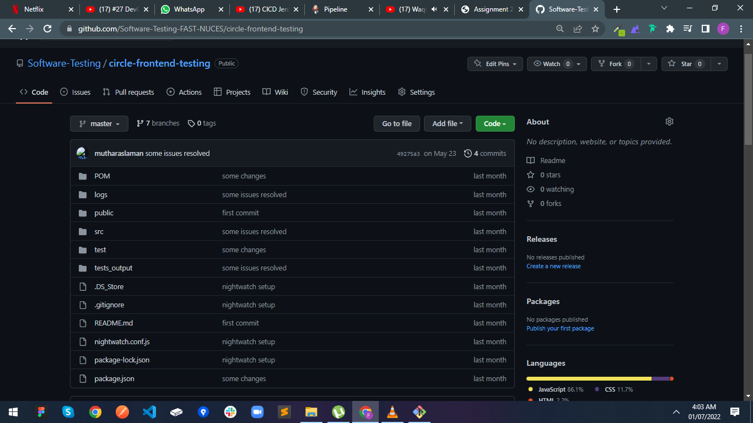

**Code Github Link for validation :**

https://github.com/Softtware-Testing/circle-frontend-testing.git

**Execution Steps:**

1. Java installation:

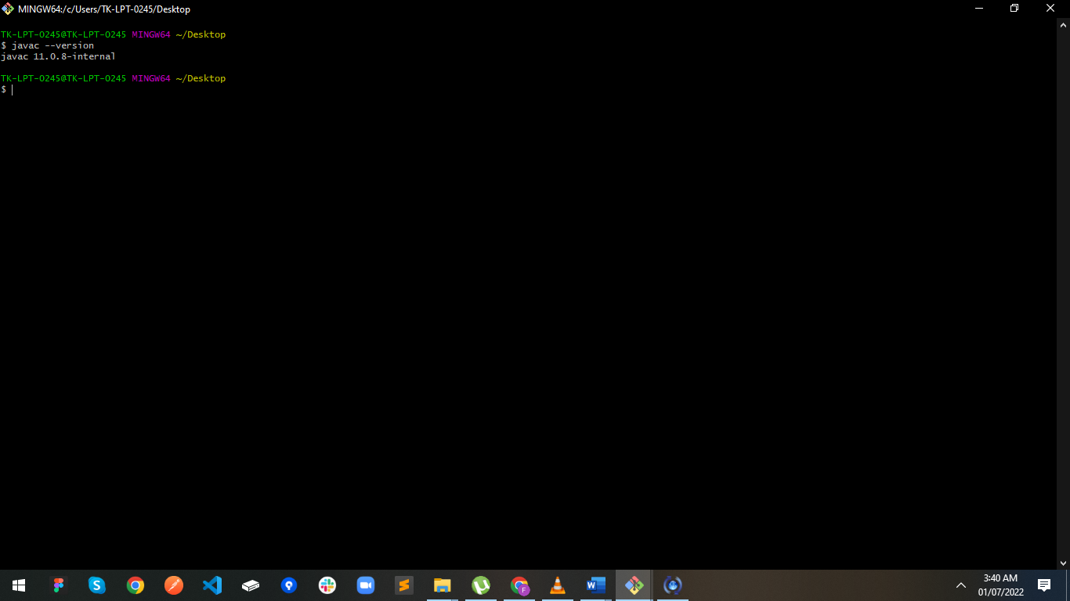

1. Jenkins boot up:

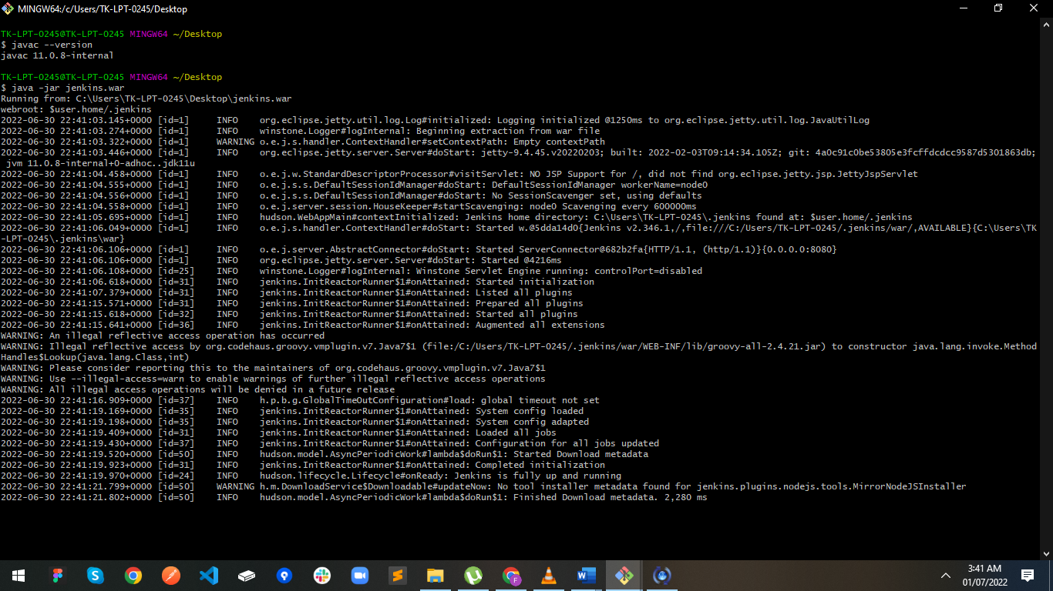

1. Jenkins Successfully started (running on local machine’s port 8080):

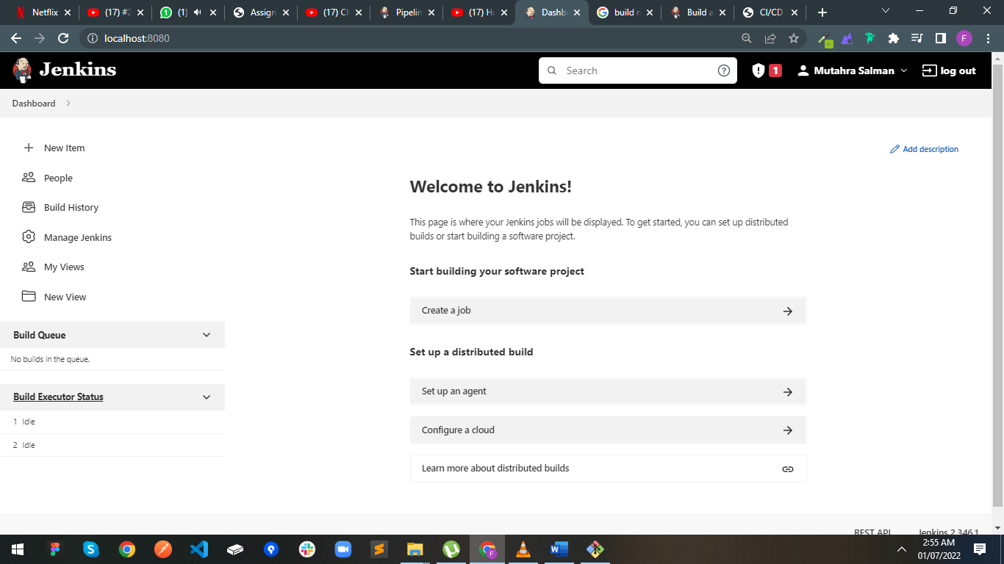

1. Created a pipeline for my NODE + REACT application

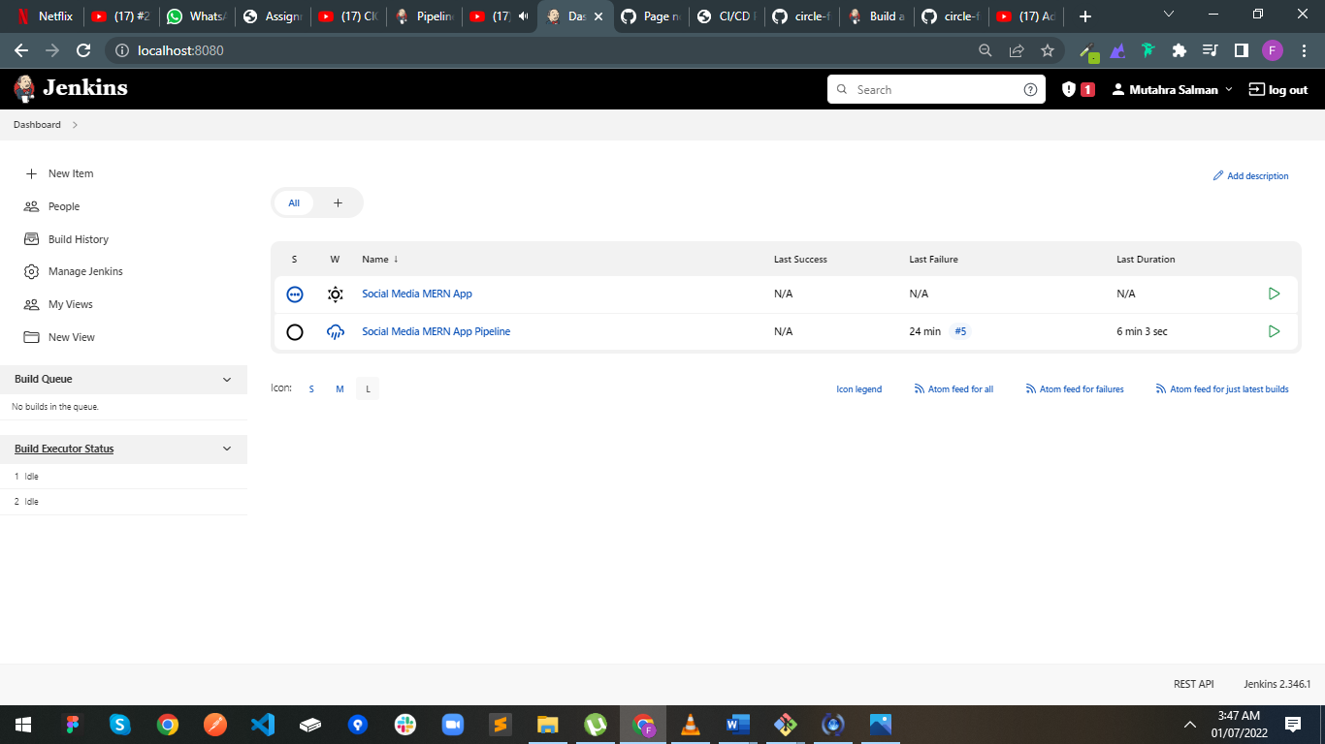

1. Configuring for My Node application:

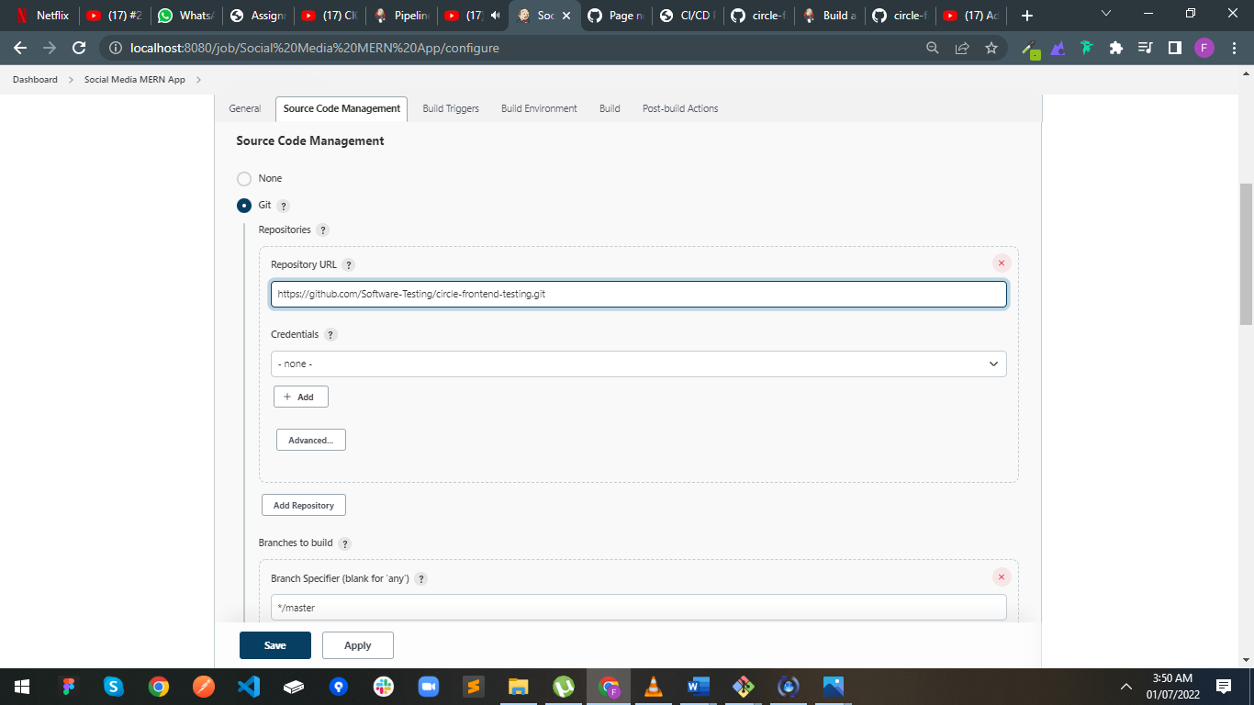

1. Configuring Build Environment:

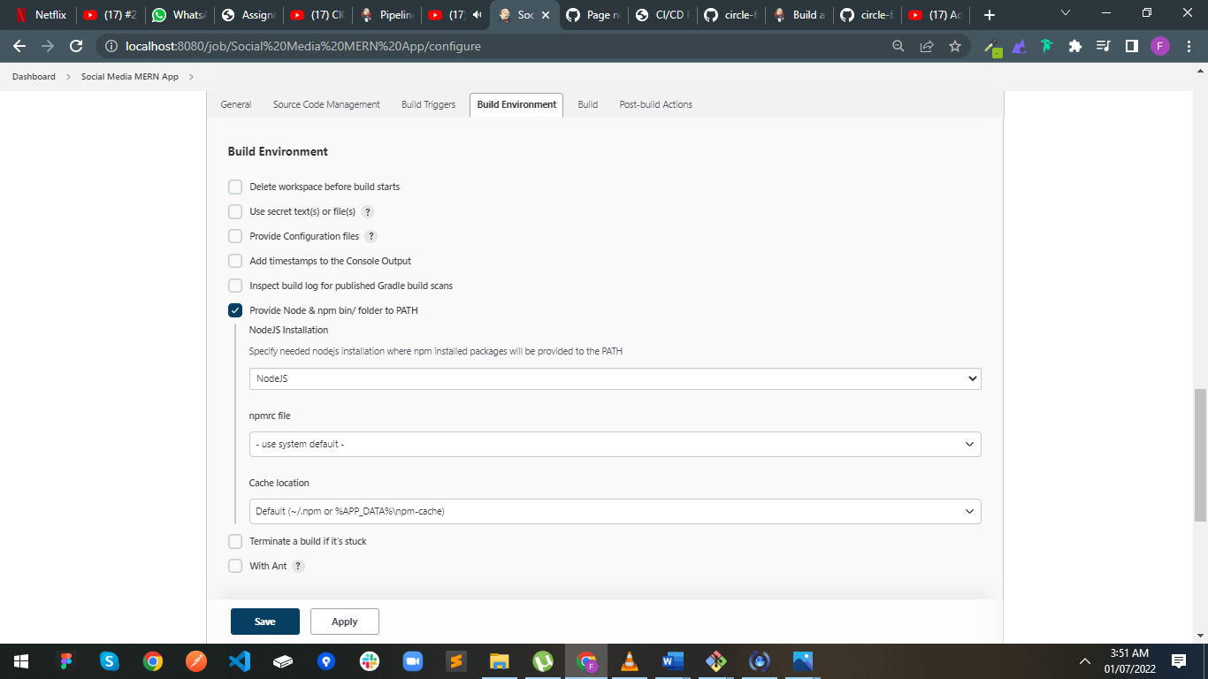

1. Writing Pipeline Code into my jerkins job:

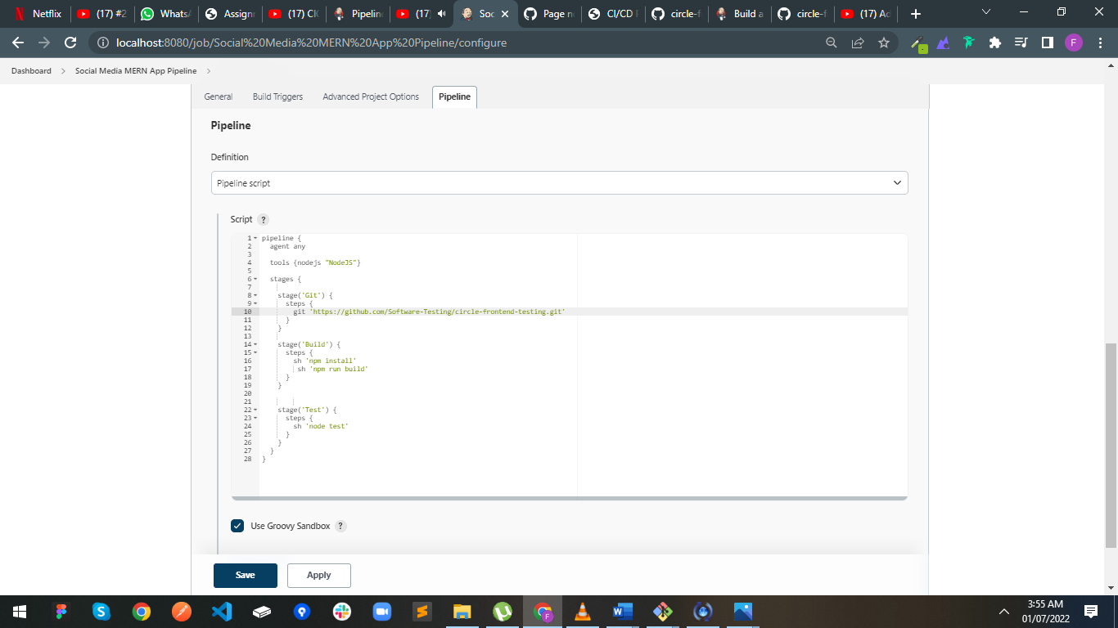

1. Running my pipeline:

